**Send email from localhost/WAMP Server using sendmail**

Posted by [Nikunj Bhatt](http://blog.techwheels.net/author/admin/" \o "View all posts by Nikunj Bhatt) on February 7, 2012

*Please try the*[*previous solution [PHPMailer]*](http://blog.techwheels.net/send-email-using-wamp-server/)*first to send email from localhost. It is much more efficient.*

The new WAMP Server’s PHP and stand-alone PHP v5.3+, are now NOT available with some of the extensions required to implement the [previous solution [PHPMailer]](http://blog.techwheels.net/send-email-using-wamp-server/) (there is a workaround to install the missing extension(s), described in the linked article). So an alternate and **much less efficient (slower, but negligible low-speed for development platform (WAMP/localhost))** solution can be implemented, as below:

Solution

This solution requires sendmail.exe (a Command Line Interface (CLI) executable which accepts email from PHP, connects to an SMTP server and sends email). You will not require to use it by command, don’t bother about it :-) [Download the sendmail.zip](http://www.glob.com.au/sendmail/sendmail.zip) and follow these steps:

* Create a folder named “sendmail” in “C:\wamp\”.
* Extract these 4 files in “sendmail” folder: “sendmail.exe”, “libeay32.dll”, “ssleay32.dll” and “sendmail.ini”.
* Open the “sendmail.ini” file and configure it as following
  + smtp_server=smtp.gmail.com
  + smtp_port=465
  + smtp_ssl=ssl
  + default_domain=localhost
  + error_logfile=error.log
  + debug_logfile=debug.log+
  + auth_username=[your_gmail_account_username]@gmail.com
  + auth_password=[your_gmail_account_password]
  + pop3_server=
  + pop3_username=
  + pop3_password=
  + force_sender=
  + force_recipient=
  + hostname=localhost

*You do not need to specify any value for these properties: pop3_server, pop3_username, pop3_password, force_sender, force_recipient. The error_logfile and debug_logfile settings should be kept blank if you have already sent successful email(s) otherwise size of this file will keep increasing. Enable these log file settings if you don’t get able to send email using sendmail.*

* Enable IMAP Access in your GMail’s Settings -> Forwarding and POP/IMAP -> IMAP Access:  
  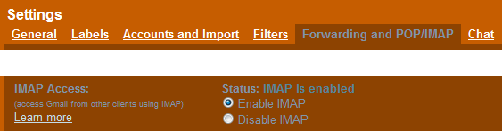
* Enable “php_openssl” and “php_sockets” extensions for PHP compiler:  
  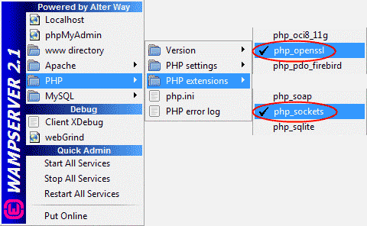
* Open php.ini from “C:\wamp\bin\apache\Apache2.2.17\bin” and configure it as following (The php.ini at “C:\wamp\bin\php\php5.3.x” would not work) (You just need to configure the last line in the following code, prefix semicolon (;) against other lines):



|  |  |
| --- | --- |
| 1  2  3  4  5  6  7  8  9  10  11  12  13  14 | [mail function]  ; For Win32 only.  ; http://php.net/smtp  ;SMTP =  ; http://php.net/smtp-port  ;smtp_port = 25    ; For Win32 only.  ; http://php.net/sendmail-from  ;sendmail_from = you@domain.com    ; For Unix only.  You may supply arguments as well (default: "sendmail -t -i").  ; http://php.net/sendmail-path  sendmail_path = "C:\wamp\sendmail\sendmail.exe -t -i" |

* Restart WAMP Server.
* Create a PHP file and write the following code in it:



|  |  |
| --- | --- |
| 1  2  3  4  5  6  7  8  9  10  11  12 | <?php  $to       = 'recipient@yahoo.com';  $subject  = 'Testing sendmail.exe';  $message  = 'Hi, you just received an email using sendmail!';  $headers  = 'From: [your_gmail_account_username]@gmail.com' . "\r\n" .              'MIME-Version: 1.0' . "\r\n" .              'Content-type: text/html; charset=utf-8';  if(mail($to, $subject, $message, $headers))      echo "Email sent";  else      echo "Email sending failed";  ?> |

* Make appropriate changes in $to and $headers variables to set recipient and sender (“From” header) addresses. Save it as “send-mail.php”. (You can save it anywhere or inside any sub-folder in “C:\wamp\www”.)
* Open this file in browser, it MUST work now :-)